Calculate the mean, median, mode and standard deviation for the problem

statements 1& 2.

**Problem Statement 1**:

The marks awarded for an assignment set for a Year 8 class of 20 students were as

follows:

6 7 5 7 7 8 7 6 9 7 4 10 6 8 8 9 5 6 4 8

**Ans :**

Mean=(5+ 7 +7+ 8+6 +7 + 7 +6 +9 +7 +4 +10 +6 +8+ 8+ 9+ 5+ 6+ 4+ 8)/20

**Mean=10.45**

Median :

Separate the numbers : 6 7 5 7 7 8 7 6 9 |7 4| 10 6 8 8 9 5 6 4 8

Calculate the average of 7,4 = (7+4)/2

**Median=5.5**

**Mode : 7**

**Problem Statement 2:**

The number of calls from motorists per day for roadside service was recorded for a

particular month:

28, 122, 217, 130, 120, 86, 80, 90, 140, 120, 70, 40, 145, 113, 90, 68, 174, 194, 170,

100, 75, 104, 97, 75,123, 100, 75, 104, 97, 75, 123, 100, 89, 120, 109

**Ans :**

**Mean= 107.51**

**Median**=(N+1)/2 th position for odd numbers

(35+1)/2=18th position is **194**

**Mode=75**

**Problem Statement 3:**

The number of times I go to the gym in weekdays, are given below along with its

associated probability:

x = 0, 1, 2, 3, 4, 5

f(x) = 0.09, 0.15, 0.40, 0.25, 0.10, 0.01

Calculate the mean no. of workouts in a week. Also evaluate the variance involved in

it.

**Please compute the following:**

a) P(Z > 1.26), . P(Z < −0.86), P(Z > −1.37), P(−1.25 < Z < 0.37), . P(Z ≤ −4.6)

b) Find the value z such that P(Z > z) = 0.05

c) Find the value of z such that P(−z < Z < z) = 0.99

a) P(Z > 1.26)= 0.8962

P(Z < −0.86)=0.1949

P(Z > −1.37)=1- P(Z < −1.37)=0.9616

P(−1.25 < Z < 0.37)=( 0.6443-0.1075-)=0.53

P(Z ≤ −4.6)=0

**b) Find the value z such that P(Z > z) = 0.05**

Ans:**1.64**

**c) Find the value of z such that P(−z < Z < z) = 0.99**

Ans : **2.576**

**Problem Statement 11:**

The current flow in a copper wire follow a normal distribution with a mean of 10 mA

and a variance of 4 (mA)2.

What is the probability that a current measurement will exceed 13 mA? What is the

probability that a current measurement is between 9 and 11mA? Determine the

current measurement which has a probability of 0.98.

Ans :

**Step 1**

**Standard normal distribution:**

The standard normal distribution is a special case of normal distribution. The standard normal distribution will have mean 0 and standard deviation 1. If a random variable *y*follows normal distribution with mean (m) and standard deviation (*s*), then the standard normal variable *z*will be as given below:

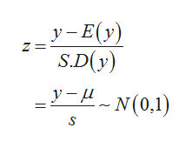

**Step 2**

**Find the probability that the curren**

**t measurement exceeds 13 milliamperes:**

Consider the current measurements in a strip of wire be denoted by *y.* It is given that the current measurements in a strip of wire are normally distributed.

The mean and standard deviation for current measurements in a strip of wire is *y-*bar = 10 milliamperes and *s*(*y*) *=*2 milliamperes, respectively.

The given requirement is that the current measurement in a strip of wire should be greater than 13 milliamperes. That is, *y*> 13.

The value of *P*(*y*> 13) is obtained as 0.06681 from the calculation given below:

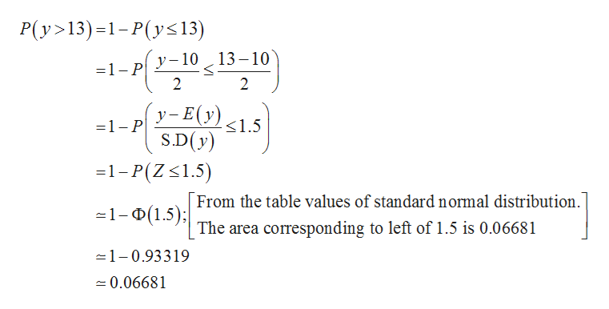

**Step 3**

**Find the probability that the current measurement lies between 9 and 11 milliamperes:**

The given requirement is that the current measurement in a strip of wire should lie between 9 and 11 milliampe...

